 | Pregnancy and Birth Validation Test - Task 11  Name: ________________________ Date: ___________  _________/ 50 = _____________%  Worth 8% Mark Allocation
Instructions to candidates

Write your answers to the short answer section in the spaces provided beneath each question
Answers that require a numerical answer should show all working out in logical steps.
Candidates should write clearly with a pen unless otherwise directed

- The placenta has many roles during pregnancy. For example maternal and foetal blood are prevented from mixing across the placenta to the foetus.
- State two reasons why maternal and foetal blood should not mix. (2 marks)
- _Reduce risk of bacterial infection_________________________
- __If mother and babies blood not same type, mother body will try to reject baby_
- List three other roles of the placenta. (3 marks)
- ____(any three) Respiration, nutrition, Excretion, Protection, Immunity, Endocrine, __
- _________________________________________________________________________________
- _________________________________________________________________________________

- Complete this table by putting ticks in the correct columns regarding the substances that can pass across the placental membrane. (4 marks)
Substance | From mother to embryo | From embryo to mother
Oxygen | yes | no
Food | yes | no
Alcohol | yes | no
Viruses (e.g. HIV) | yes | yes

The diagram below shows a developing foetus in the placenta.  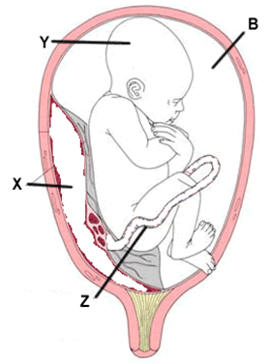 | Label the left diagram. (4 marks)  B: ___Amniotic Fiud_______________  X: Placenta____________________________  Y: _______foetus_____________________________  Z: _______Umbilical Cord______________________

- As the foetus grows within the uterus the females’ abdomen begins to bulge. Describe what you think would happen to the internal organs that are close to the expanding uterus. (2 marks)
your liver and your lungs get squeezed by your stomach and intestines_____________________
_ the bladder gets compressed (flattened), making less space for urine.____________________

Questions 4 and 5 refer to the diagram below.
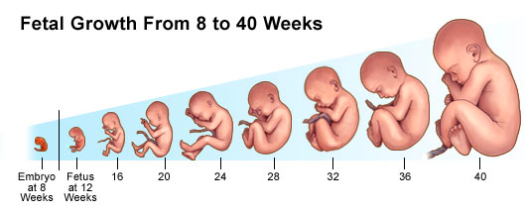

- On the diagram above, label the three trimesters. At 0-13, 14-26, 27-40 (3 marks)

- For each of the three trimesters, explain the key events in the development of the foetus.
(6 marks)

Trimester |  | Key Events
1 |  | Cell division and differentiation.  Development of body structure and major internal organs  Nostrils, mouth, lips, teeth buds, and eyelids form
2 |  | Feotus grows to 8-10 inches  The fetus kicks, moves and can turn from side to side.  The eyes have been gradually moving to the front of the face, and the ears have moved from the neck to the sides of the head.  The fetus can hear your voice.  Eyelashes, eye brows  Fat deposits develop
 | 3 | Grows to birth size.  Active and rests.  Use four senses  Rotates preparing for birth  Takes antibodies from mother

- Describe and explain events that take place during each of the THREE stages of the birth process. (3 marks)
- _ 1. Dilation Contractions force the baby’s head into the cervix, stretching the cervix to a 10 cm opening (cervical dilation). At this stage the ‘waters’ usually ‘break’ (i.e. the amnion bursts and releases the amniotic fluid._________
- __ 2. Expulsion Contractions become stronger and more frequent Lasts 10min – 2 hours. Each contraction advances the head a small amount. Head stretches entrance to vagina. The head emerges the baby rotates side on so shoulders can follow. Out comes baby.___________________
- The placental stage A final contraction of the uterus expels the placenta, umbilical cord and membranes (the after-birth) from the mother’s body. Blood in mother clots stopping bleeding_________________________________________________________________
- Breastfeeding is recommended for all newborn babies; however in some cases the newborn baby needs to be bottle-fed. Describe THREE advantages for each method of providing nourishment to a newborn baby. (6 marks)
Breast – antibodies, easily digested, less constipation or diarrhea, cheaper, can lower disease in mother
Bottle – Consistent level of nutrition to baby, share feeding duties, less digestible therefore less feeds, Don’t have to worry about what mum eat.____________

- A) What is colostrum?
The first milk that lasts between two and four days after birth.____ (1 mark)
- How does colostrum differ from milk?
Cl richer in protein, immunoglobulin, lactoferrin, less sugar, less. _ (1 mark)
____________________________________________________________________________________

- Motor skills are motions carried out when the brain, nervous system and muscles work together. Fine motor skills are small movements – that use the muscles of the fingers, toes, wrists, lips and tongue. Gross motor skills are the bigger movements – that use the large muscles in the arms, legs, torso and feet. Using this information, tick the box for which skills are being developed during infancy. The age of infancy is: _____________________(1 mark)
Infancy development | Gross motor | Fine motor
Plays with fingers at 5 months | no | yes
Can lift head at 3 months when lying on front | yes | no
Able to grasp an object at 6 months | no | yes
Pulls into a standing position at 8 months, holding onto things | yes | no
Can hold small crayons | no | yes
 |  | (5 marks)

- Define the term ‘secondary sexual characteristics’. Give two examples for these in the female and two examples in the male. (5 marks)
Secondary sex characteristics are features that appear during puberty in humans, that distinguish the sexes of a species,^{[3]} but unlike the sex organs (primary sex characteristics), are not directly part of the reproductive system__________________
Female:
Enlargement of breasts and erection of nipples.
Growth of body hair, most prominently underarm and pubic hair.
Widening of hips;[4][6] lower waist to hip ratio than adult males.
Elbows that hyperextend 5–8° more than male adults.
Upper arms approximately 2 cm longer, on average, for a given height.
Labia minora, the inner lips of the vulva, may grow more prominent and undergo changes in color with the increased stimulation related to higher levels of estrogen.
Male _
Growth of body hair, including underarm, abdominal, chest hair and pubic hair.
Growth of facial hair.
Enlargement of larynx (Adam's apple) and deepening of voice.
Increased stature; adult males are taller than adult females, on average.
Heavier skull and bone structure.
Increased muscle mass and strength.
Broadening of shoulders and chest; shoulders wider than hips.
Increased secretions of oil and sweat glands.
- _

- Females have relatively more body fat than males, and less muscle mass. As a consequence, female sporting prowess has often been overshadowed by that of males. For example, the marathon for women was only added to the events in the Olympic Games in 1984. What changes occur in males during adolescence that result in their greater muscle mass and strength. (4 marks)
- Rising levels of male hormones, such as testosterone, that cause an increase in muscle mass.
- Bone development leading to broader at the shoulders and more tapered at the waist, forming the familiar triangular shape of adult males.

END OF TEST

